**Homework (Simulation) Wan Huzaifah bin Wan Azhar**

This program, lottery.py, allows you to see how a lottery scheduler works. See the README for details.

**Answer:**

1. Compute the solutions for simulations with 3 jobs and random seeds of 1, 2 and 3.

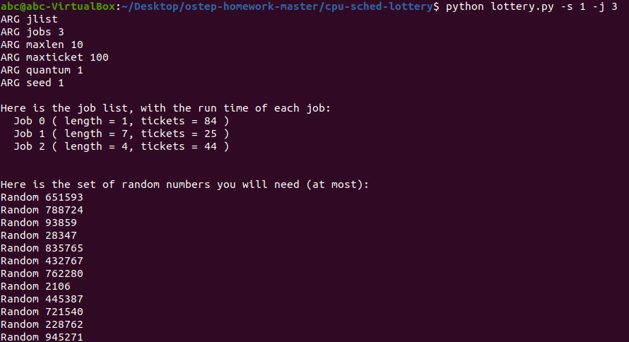

Random 651593 -> Winning ticket 119 (of 153) -> Run 2  
Jobs:  
(job:0 timeleft: 1)(job:1 timeleft: 7)(job:2 timeleft: 4)

Random 788724 -> Winning tickets 9 (of 153) -> Run 0  
Jobs:  
(job:0 timeleft: 1)(job:1 timeleft: 7)(job:2 timeleft: 3)  
--> JOB 0 DONE at time 2

Random 93859 -> Winning tickets 19 (of 69) -> Run 1  
Jobs:  
(job:0 timeleft: 0)(job:1 timeleft: 7)(job:2 timeleft: 3)

Random 28347 -> Winning tickets 57 (of 69) -> Run 2  
Jobs:  
(job:0 timeleft: 0)(job:1 timeleft: 6)(job:2 timeleft: 3)

Random 835765 -> Winning tickets 37 (of 69) -> Run 2  
Jobs:  
(job:0 timeleft: 0)(job:1 timeleft: 6)(job:2 timeleft: 2)

Random 432767 -> Winning tickets 68 (of 69) -> Run 2  
Jobs:  
(job:0 timeleft: 0)(job:1 timeleft: 6)(job:2 timeleft: 1)  
--> JOB 1 DONE at time 6

Random 762280 -> Winning tickets 5 (of 25) -> Run 1  
Jobs:  
(job:0 timeleft: 0)(job:1 timeleft: 6)(job:2 timeleft: 0)

Random 2106 -> Winning tickets 6 (of 25) -> Run 1  
Jobs:  
(job:0 timeleft: 0)(job:1 timeleft: 5)(job:2 timeleft: 0)

Random 445387 -> Winning tickets 12 (of 25) -> Run 1  
Jobs:  
(job:0 timeleft: 0)(job:1 timeleft: 4)(job:2 timeleft: 0)

Random 721540 -> Winning tickets 15 (of 25) -> Run 1  
Jobs:  
(job:0 timeleft: 0)(job:1 timeleft: 3)(job:2 timeleft: 0)

Random 228762 -> Winning tickets 12 (of 25) -> Run 1  
Jobs:  
(job:0 timeleft: 0)(job:1 timeleft: 2)(job:2 timeleft: 0)

Random 945271 -> Winning tickets 21 (of 25) -> Run 1  
Jobs:  
(job:0 timeleft: 0)(job:1 timeleft: 1)(job:2 timeleft: 0)  
--> JOB 1 DONE at time 12

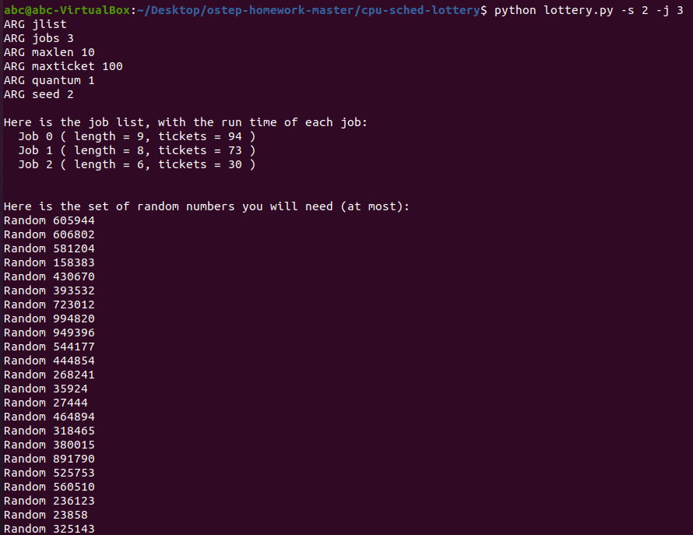

Random 605944 -> Winning ticket 169 (of 197) -> Run 2  
Jobs:  
(job:0 timeleft: 9)(job:1 timeleft: 8)(job:2 timeleft: 6)

Random 606802 -> Winning tickets 42 (of 197) -> Run 0  
Jobs:  
(job:0 timeleft: 9)(job:1 timeleft: 8)(job:2 timeleft: 5)

Random 581204 -> Winning tickets 54 (of 197) -> Run 0  
Jobs:  
(job:0 timeleft: 8)(job:1 timeleft: 8)(job:2 timeleft: 5)

Random 158383 -> Winning tickets 192 (of 197) -> Run 2  
Jobs:  
(job:0 timeleft: 7)(job:1 timeleft: 8)(job:2 timeleft: 5)

Random 430670 -> Winning tickets 28 (of 197) -> Run 0  
Jobs:  
(job:0 timeleft: 7)(job:1 timeleft: 8)(job:2 timeleft: 4)

Random 393532 -> Winning tickets 123 (of 197) -> Run 1  
Jobs:  
(job:0 timeleft: 6)(job:1 timeleft: 8)(job:2 timeleft: 4)

Random 723012 -> Winning tickets 22 (of 197) -> Run 0  
Jobs:  
(job:0 timeleft: 6)(job:1 timeleft: 7)(job:2 timeleft: 4)

Random 994820 -> Winning tickets 167 (of 197) -> Run 2  
Jobs:  
(job:0 timeleft: 5)(job:1 timeleft: 7)(job:2 timeleft: 4)

Random 949396 -> Winning tickets 53 (of 197) -> Run 0  
Jobs:  
(job:0 timeleft: 5)(job:1 timeleft: 7)(job:2 timeleft: 3)

Random 544177 -> Winning tickets 63 (of 197) -> Run 0  
Jobs:  
(job:0 timeleft: 4)(job:1 timeleft: 7)(job:2 timeleft: 3)

Random 444854 -> Winning tickets 28 (of 197) -> Run 0  
Jobs:  
(job:0 timeleft: 3)(job:1 timeleft: 7)(job:2 timeleft: 3)

Random 268241 -> Winning tickets 124 (of 197) -> Run 1  
Jobs:  
(job:0 timeleft: 2)(job:1 timeleft: 7)(job:2 timeleft: 3)

Random 35924 -> Winning tickets 70 (of 197) -> Run 0  
Jobs:  
(job:0 timeleft: 2)(job:1 timeleft: 6)(job:2 timeleft: 3)

Random 27444 -> Winning tickets 61 (of 197) -> Run 0  
Jobs:  
(job:0 timeleft: 1)(job:1 timeleft: 6)(job:2 timeleft: 3)  
--> JOB 0 DONE at time 14

Random 464894 -> Winning tickets 55 (of 103) -> Run 1  
Jobs:  
(job:0 timeleft: 0)(job:1 timeleft: 6)(job:2 timeleft: 3)

Random 318465 -> Winning tickets 92 (of 103) -> Run 2  
Jobs:  
(job:0 timeleft: 0)(job:1 timeleft: 5)(job:2 timeleft: 3)

Random 380015 -> Winning tickets 48 (of 103) -> Run 1  
Jobs:  
(job:0 timeleft: 0)(job:1 timeleft: 5)(job:2 timeleft: 2)

Random 891790 -> Winning tickets 16 (of 103) -> Run 1  
Jobs:  
(job:0 timeleft: 0)(job:1 timeleft: 4)(job:2 timeleft: 2)

Random 525753 -> Winning tickets 41 (of 103) -> Run 1  
Jobs:  
(job:0 timeleft: 0)(job:1 timeleft: 3)(job:2 timeleft: 2)

Random 560510 -> Winning tickets 87 (of 103) -> Run 2  
Jobs:  
(job:0 timeleft: 0)(job:1 timeleft: 2)(job:2 timeleft: 2)

Random 236123 -> Winning tickets 47 (of 103) -> Run 1  
Jobs:  
(job:0 timeleft: 0)(job:1 timeleft: 2)(job:2 timeleft: 1)

Random 23858 -> Winning tickets 65 (of 103) -> Run 1  
Jobs:  
(job:0 timeleft: 0)(job:1 timeleft: 1)(job:2 timeleft: 1)  
--> JOB 1 DONE at time 22

Random 325143 -> Winning tickets 3 (of 30) -> Run 2  
Jobs:  
(job:0 timeleft: 0)(job:1 timeleft: 0)(job:2 timeleft: 1)  
--> JOB 2 DONE at time 23

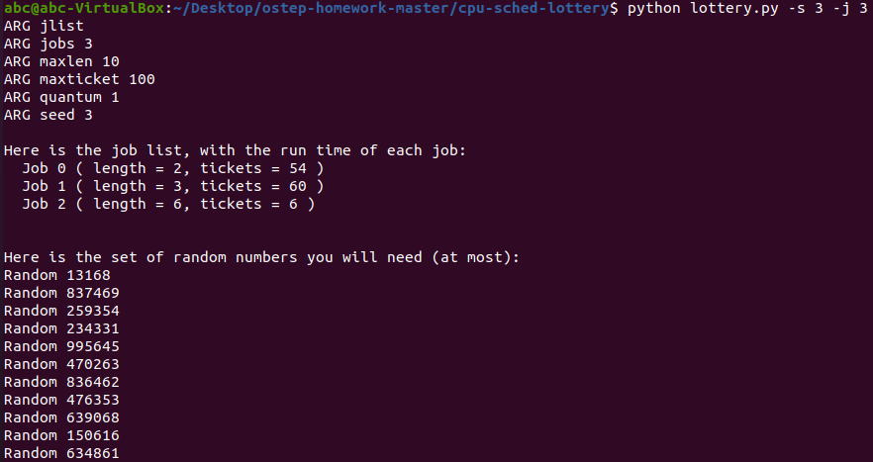

Random 13168 -> Winning ticket 88 (of 120) -> Run 1  
Jobs:  
(job:0 timeleft: 2)(job:1 timeleft: 3)(job:2 timeleft: 6)

Random 837469 -> Winning tickets 109 (of 120) -> Run 1  
Jobs:  
(job:0 timeleft: 2)(job:1 timeleft: 2)(job:2 timeleft: 6)

Random 259354 -> Winning tickets 34 (of 120) -> Run 0  
Jobs:  
(job:0 timeleft: 2)(job:1 timeleft: 1)(job:2 timeleft: 6)

Random 234331 -> Winning tickets 91 (of 120) -> Run 1  
Jobs:  
(job:0 timeleft: 1)(job:1 timeleft: 1)(job:2 timeleft: 6)  
--> JOB 1 DONE at time 4

Random 995645 -> Winning tickets 5 (of 60) -> Run 0  
Jobs:  
(job:0 timeleft: 1)(job:1 timeleft: 0)(job:2 timeleft: 6)  
--> JOB 0 DONE at time 5

Random 470263 -> Winning tickets 1 (of 6) -> Run 2  
Jobs:  
(job:0 timeleft: 0)(job:1 timeleft: 0)(job:2 timeleft: 6)

Random 836462 -> Winning tickets 2 (of 6) -> Run 2  
Jobs:  
(job:0 timeleft: 0)(job:1 timeleft: 0)(job:2 timeleft: 5)

Random 476353 -> Winning tickets 1 (of 6) -> Run 2  
Jobs:  
(job:0 timeleft: 0)(job:1 timeleft: 0)(job:2 timeleft: 4)

Random 639068 -> Winning tickets 2 (of 6) -> Run 2  
Jobs:  
(job:0 timeleft: 0)(job:1 timeleft: 0)(job:2 timeleft: 3)

Random 150616 -> Winning tickets 4 (of 6) -> Run 2  
Jobs:  
(job:0 timeleft: 0)(job:1 timeleft: 0)(job:2 timeleft: 2)

Random 634861 -> Winning tickets 1 (of 6) -> Run 2  
Jobs:  
(job:0 timeleft: 0)(job:1 timeleft: 0)(job:2 timeleft: 1)  
--> JOB 2 DONE at time 11

1. **Now run with two specific jobs: each of length 10, but on (job 0) with just 1 ticket and the other (job 1) with 100 (e.g., -1 10:1, 10:100). What happens when the number of tickets is so imbalanced? Will job 0 ever run before job 1 completes? How often? In general, what does such ticket imbalance do to the behavior of lottery scheduling?**

* When the tickets are imbalance, e.g., 100 to 1, the job with lowest ticket will rarely ever get to run before the other ticket is finished.
* Job 0 will run if the lottery randomly generates a number that selects Job 0. But the chance will be seldom, and the job will only run at most 1 time before Job 1 is complete.
* The imbalance of ticket will cause the job with most ticket to be prioritized over job with lowest ticket. Instead of randomness, the lottery scheduler will become a priority scheduler.

1. **When running with two jobs of length 100 and equal ticket allocations of 100 (-l 100:100, 100:100), how unfair is the scheduler? Run with some different random seeds to determine the (probabilistic) answer; let unfairness be determined by how much earlier one job finishes than the other.**

* The scheduler is very unfair.
* Of 10 seeds, there are only two times Job 0 finish first before Job 1.
* Therefore, Job 0 finish first only 3/10 times, which is 30%.
* It does look unfair, but as each job has the same ticket and length, one of the jobs must finish first and by chance, 7 of 10 times, Job 1 finish first before Job 0.
* Therefore, the scheduler is unfair because it is random.
* It is random because the winning ticket is randomized.

1. **How does your answer to the previous question change as the quantum size (-q) gets larger?**

* As quantum size gets larger (100), the scheduler is being very fair.
* Of 10 seeds, Job 0 and Job 1 has 50% chance of finishing first.
* This is because when quantum size is set at large value, the winning ticket is 50/50 to Job 0 or Job 1.
* As such, both job have good chance of finishing first.

1. **Can you make a version of the graph that is found in the chapter? What else would be worth exploring? How would the graph look with a stride scheduler?**

* Graph:
* What is worth exploring is how would the graph look when comparing same length but different quantum size.
* With stride scheduler, the above graph would be close to 1 even when the length is low as 1 or 10.
* Stride scheduler will optimize for fairness, as two jobs with length 10 and 10 ticket will run together side by side.
* At the end, both jobs will finish at time 9 and 10.
* 9/10 = 0.9 which is much better than lottery fairness.